SUN Pharma- Change Request Approval Process

Software Requirement & Design Specifications

Developed by: Harshit Chaubey
From (07th June 2022- 5th Aug 2022)



Acknowledgement

I have taken efforts in this project. However, it would not have been possible without the kind support and help of many individuals and organizations. I would like to extend my sincere thanks to all of them.

I am highly indebted to Jigar Gohil sir, Sanjiv Jain sir and Gouri Prasad Nanda sir for their guidance and constant supervision as well as for providing necessary information regarding the project & also for their support in completing the project.

I would like to express my gratitude towards my parents & member of Sun pharma for their kind co-operation and encouragement which help me in completion of this project.

I would like to express my special gratitude and thanks to industry persons for giving me such attention and time.

My thanks and appreciations also go to my colleague in developing the project and people who have willingly helped me out with their abilities.

Harshit Chaubey

SUN Pharma- Change Request Approval Process

Software Requirement Specifications
Version 1.0, August 5, 2022

Submitted to:
Sun Pharmaceutical
IT
Mumbai, India

Document Release Note
Document Details
Project Number
Document Name | Software Requirement Specifications
Document No. | 1.0
Version No. | 1.0
Release Date | August 5, 2022

Revision Details
No | Revision | Date | Author | Description
1 | 1.0 | August 5, 2022 | Harshit Chaubey | Initial Version

Document Approval
Name |  | Title | Signature | Date
Prepared | Harshit Chaubey | Trainee |  | August 5, 2022
Reviewed | Gouri Prasad Nanda | Sr.Manager(IT) |  | August 5, 2022
Approved
Sun Pharmaceutical
Approved

Distribution to:
Sun Pharmaceutical

Contents
1. Document Summary 1
1.1 Purpose 1
1.2 Overview 1
2. PROJECT DETAILS 2
2.1 Project name 2
2.2 Customer name 2
3. Brief Description About Client Business 3
4. Objective 4
5. Scope 5
5.1 Customer Requirements List 5
6. Target Users 6
7. System Architecture 7
8. Features and Understanding 8
8.1 Raise New Change Request 8
8.1.1 Overview 8
8.1.2 Prototype 8
8.1.3 Business Logic and Validations 8
8.2 User Reporting Manager & Business Sponsor Approval 12
8.2.1 Overview 12
8.2.2 Prototype 12
8.2.3 Business Logic and Validations 12
8.3 IT Portfolio Manager Approval 14
8.3.1 Overview 14
8.3.2 Prototype 14
8.3.3 Business Logic and Validations 14
8.4 IT Project Manager Approval 16
8.4.1 Overview 16
8.4.2 Prototype 16
8.4.3 Business Logic and Validations 16
8.5 Final IT Portfolio Manager Approval 19
8.5.1 Overview 19
8.5.2 Prototype 19
8.5.3 Business Logic and Validations 19
9. Tools / Technologies / Third Party Components 21
10. Future Scope 22
11. Conclusion 23

Click or tap here to enter text.

Document Summary

Purpose
Purpose of this document is to outline the understanding of the Change Request Approval process digitization at Sun Pharmaceutical using software asp.net MVC and Entity Framework and database Ms-SQL.

Overview
This document provides the understanding of Change Request Approval process. Correctness of the process ensures an appropriate level of information and the necessary approval activities. Specifically, this document describes the functional aspect of the requirements of the Change Request Approval process at Sun Pharmaceutical.

PROJECT DETAILS

Project name
SUN Pharma - Change Request Approval

Customer name
Sun Pharmaceutical Ind. Ltd.

Brief Description About Client Business

Sun Pharmaceutical Industries Ltd. (Sun Pharma) is the fourth largest specialty generic pharmaceutical company in the world with global revenues of over US$ 4.5 billion. Supported by more than 40 manufacturing facilities, and provides high-quality, affordable medicines, trusted by healthcare professionals and patients, to more than 100 countries across the globe.
Sun Pharma is headquartered in Mumbai, Maharashtra that manufactures and sells pharmaceutical formulations and active pharmaceutical ingredients (APIs) primarily in India and the United States. Sun Pharma produce a comprehensive, diverse and highly complementary portfolio of generic and specialty medicines targeting a wide spectrum of chronic and acute treatments. The product portfolio includes generics, branded generics, speciality, difficult-to-make technology intensive products, over-the-counter (OTC), anti-retrovirals (ARVs), Active Pharmaceutical Ingredients (APIs) and intermediates. It is present in more than 100 countries and catering to local treatment needs while continually improving its global product offering.

Objective
Objectives and functions of Change Request Approval Process can be summarized as follows:
Change Request Approval Process is an application where user Initiate New Change Request which he/she thinks might be useful for the organisation. Also, approvers can Approve/Reject the Change Request which has been assigned to him/her by the Initiator.
There are 2 core functionalities of this project viz.
- Initiate a request for New Project
- Approve/Reject the requests for New application

There are 5 levels of Approvals present in the tool-
Initiator > Reporting Manager > Business Sponsor > IT Portfolio Manager > IT Project Manager > IT Portfolio Manager
- Initiator initiates the request with project details and requirements, which goes to Reporting Manager for approval.
- Reporting Manager can approve/reject the request. On approval it goes to Business Sponsor and on Rejection it goes back to Initiator.
- Business Sponsor can approve the request and send to IT Portfolio Manager or Reject the request and send it back to Initiator.
- The IT Portfolio Manager sends the request to IT Project Manager for review and feedback.
- The IT Project Manager adds the impact assessment details and his feedback and send it back to IT Portfolio Manager.
- Finally, IT Portfolio Manager reviews the assessment details and feedback and finally Approve/Reject the request and Change Request approval process will be completed.
- All users can view status of the process anytime using the status report.
- All approvals and rejections are communicated to users by emails.

Scope

Customer Requirements List
Table 1: Customer Requirements List
# | Requirement | Type (Business, IT,Security, UI, Data Archival)
1 | Initiate Request for New Project | Business
2 | Approval of the request by the Reporting Manager of the initiator. | Business
3 | Approval of the request by Business Sponsor | Business
4 | Approval of the request by IT Portfolio Manager | IT
5 | Approval of the request by IT Project Manager | IT
6 | Final Approval of the request by IT Portfolio Manager | IT

Target Users
Raise Change Request –
Initiator: All users can be initiators
Level 1 Approval –
Reporting Manager of the Initiator
Level 2 Approval –
Business Sponsor
Level 3 Approval –
IT Portfolio Manager
Level 4 Approval –
IT Project Manager
Level 5 Approval
IT Portfolio Manager

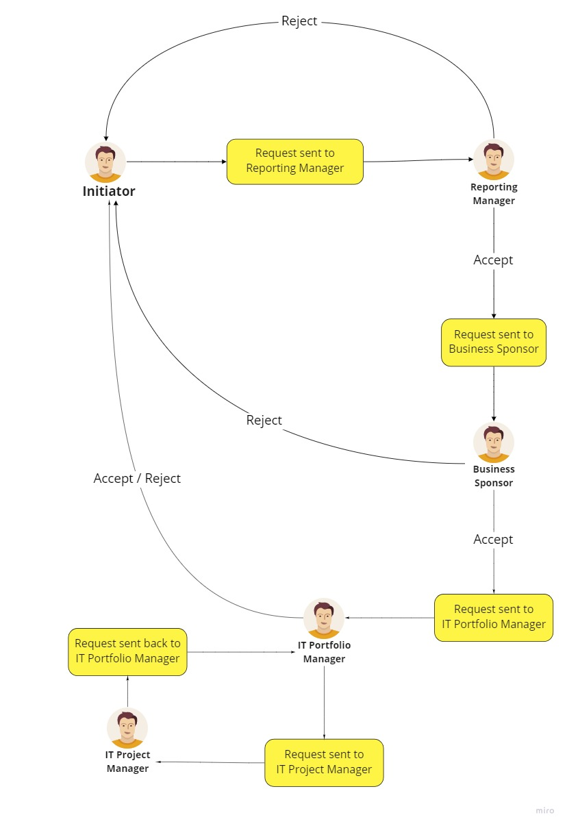
System Architecture

Features and Understanding

Raise New Change Request

Overview
Initiator will login to Change Request Approval application. User will redirect to the home page.
Initiation can raise a new request using the menu: Request -> new request option.

User need to complete the form like project description, justification and requirements etc. to submit the Change Request to next level approver i.e. Reporting Manager (RM).
User also can save the screen data as draft to submit it later. Email notification will be sent to RM on submitting the request.

Prototype
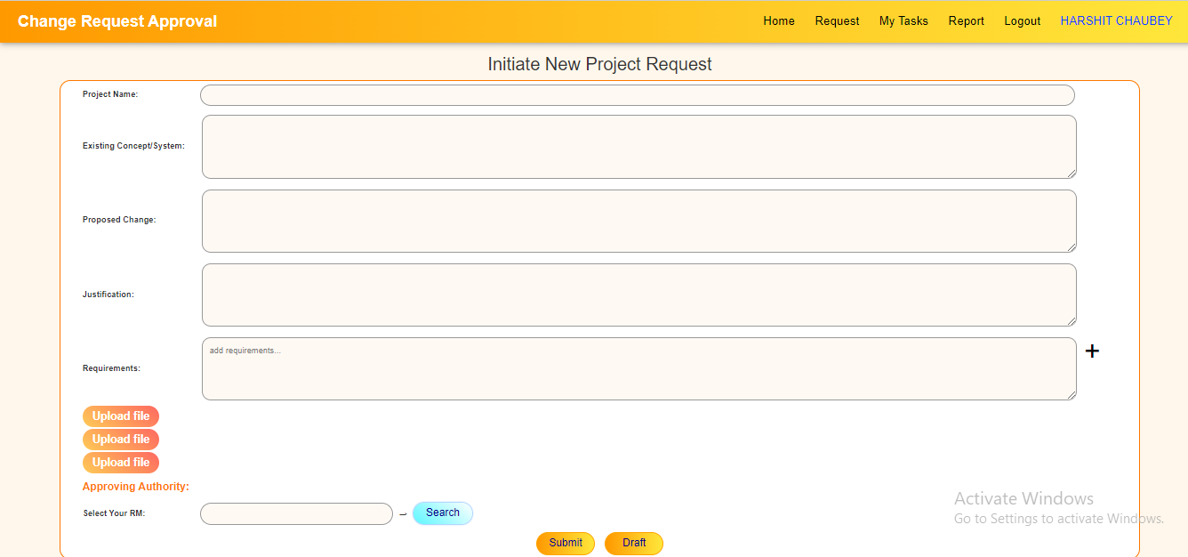
Below please find a mock-up Change Request form screen.

Business Logic and Validations
Following are the fields that will be appearing based on the business login in the request form.
Table 2: Raise Change Request form Field Business Logic 1
Field Name | Project name
Input Format | Text Box
Maximum Length | 99
Default Value | N/A
Data Entered By | User will enter value
Validation | Mandatory to enter value
Business Rules | N/A
Table 3: Raise Change Request form Field Business Logic 2
Field Name | Existing Concept/System
Input Format | Text Box [Multiline] (1 X 4 rows)
Maximum Length | 4000
Default Value | N/A
Data Entered By | User will enter value
Validation | Mandatory to submit.  Not Mandatory to draft.
Business Rules | N/A
Table 4: Raise Change Request form Field Business Logic 3
Field Name | Proposed Change
Input Format | Text Box [Multiline] (1 X 4 rows)
Maximum Length | 4000
Default Value | N/A
Data Entered By | User will enter value
Validation | Mandatory to submit.  Not Mandatory to draft.
Business Rules | N/A
Table 5: Raise Change Request form Field Business Logic 4
Field Name | Justification
Input Format | Text Box [Multiline] (1 X 4 rows)
Maximum Length | 4000
Default Value | N/A
Data Entered By | User will enter value
Validation | Mandatory to submit.  Not Mandatory to draft.
Business Rules | N/A
Table 6: Raise Change Request form Field Business Logic 5
Field Name | Requirements
Input Format | Text Box [Multiline] (1 X 4 rows)
Maximum Length | 4000
Default Value | N/A
Data Entered By | User will enter value
Validation | Mandatory to submit.  Not Mandatory to draft.
Business Rules | Click + button to add more requirements.  Click x button to delete requirements  Max: 10 requirements allowed
Table 7: Raise Change Request form Field Business Logic 6
Field Name | Upload File x 3
Input Format | file
Maximum Length | Max 5MB file size
Default Value | N/A
Data Entered By | User will upload file
Validation | Not Mandatory to submit/draft.
Business Rules | N/A
Table 8: Raise Change Request form Field Business Logic 7
Field Name | Select Your R
Input Format | Disabled text
Maximum Length | 100
Default Value | N/A
Data Entered By | Auto-populated on “Manager selection”
Validation | Mandatory to submit.  Not Mandatory to draft.
Business Rules | N/A
Table 9: Raise Change Request form Field Business Logic 8
Field Name | Submit
Input Format | Button
Maximum Length | N/A
Default Value | N/A
Data Entered By | N/A
Validation | N/A
Business Rules | On click of this button, system will validate the form and submit the request. On submit the request will be sent to the RM approver with email notification.

Table 10: Raise Change Request form Field Business Logic 9
Field Name | Draft
Input Format | Button
Maximum Length | N/A
Default Value | N/A
Data Entered By | N/A
Validation | N/A
Business Rules | On click of this button, system will store the input field values that were entered by the user for later use.

User Reporting Manager & Business Sponsor Approval

Overview
Once the initiator submits the request, it will be send to “User Reporting Manager”.
Post logging in to the application the user Reporting Manager needs to go to the My Tasks page. The user can view & act on all the request assigned. The user will have the option to view the data entered in the previous stage in non-editable mode. The user need to enter remarks and Approve (Yes/No) on this request for both approval and rejection.
If Approved (Approve checkbox is Yes), Reporting Manager needs to select next reviewer i.e. Business Sponsor and submit request to him. System will send email notification to the Business Sponsor.
If Rejected (Approve checkbox is No), Reporting Manager don’t need to select next reviewer i.e. Business Sponsor. System will send email notification to the initiators regarding rejection.
Similarly, Post logging in to the application the Business Sponsor needs to go to My Tasks menu tor can view all the request assigned and take necessary action. The user will have the option to view the data entered in the previous stage as read only mode. The user need to enter remarks and Approve (Yes/No) on this request.
If Approved (Approve checkbox is Yes), Business Sponsor need to select next reviewer i.e. IT Portfolio Manager and submit request to him. System will send email notification to the IT Portfolio Manager.
If Rejected (Approve checkbox is No), Business Sponsor don’t need to select next reviewer i.e. IT Portfolio Manager. System will send email notification to all the users in that request that the change request has been rejected.

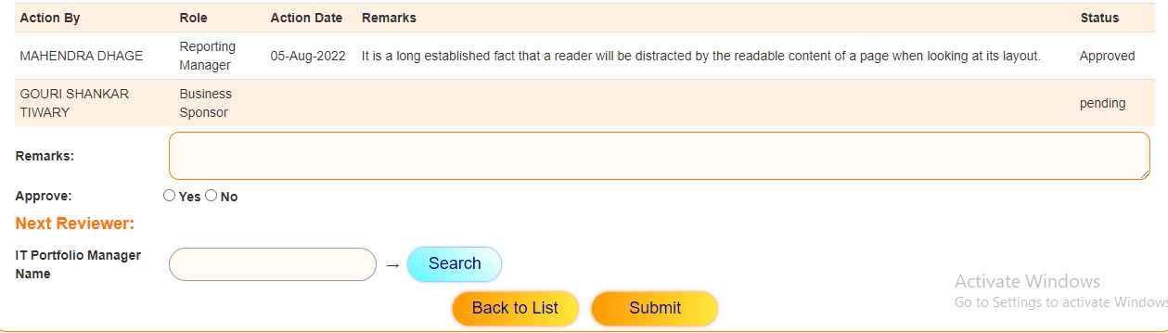
Prototype

Business Logic and Validations
Table 11: User Reporting Manager & Business Sponsor Approval form Field Business Logic 1
Field Name | Remarks
Input Format | Text Box [Multiline] (1 X 2 rows)
Maximum Length | 2000
Default Value | N/A
Data Entered By | User must enter value
Validation | Mandatory
Business Rules | N/A
Table 12: User Reporting Manager & Business Sponsor Approval form Field Business Logic 2
Field Name | Approve
Input Format | Radio Button
Maximum Length | N/A
Default Value | N/A
Data Entered By | User must select yes/no
Validation | Mandatory
Business Rules | If Yes, select next reviewer.  If no, don’t next reviewer.
Table 13: User Reporting Manager & Business Sponsor Approval form Field Business Logic 3
Field Name | Next Reviewer
Input Format | Disabled Text Box
Maximum Length | N/A
Default Value | N/A
Data Entered By | Auto-populated on “Manager selection”
Validation | Mandatory if Approve = yes
Business Rules | N/A
Table 14: User Reporting Manager & Business Sponsor Approval form Field Business Logic 4
Field Name | Submit
Input Format | N/A
Maximum Length | N/A
Default Value | N/A
Data Entered By | N/A
Validation | N/A
Business Rules | On click of this button, system will validate the form and submit the request. On submit the request and mail will be sent to the Business Sponsor/ IT Portfolio Manager.

IT Portfolio Manager Approval

Overview
Once the Business Sponsor submits the request, item will be moved to the IT Portfolio Manager. Post logging in to the application the user needs to redirect to the My Tasks page. The user can view & act on all the request assigned. The user will have the option to view the data entered in the previous stage in non-editable mode. The user must enter remarks on this request and select the next reviewer i.e. Manager. On submit, email notification will be sent to the IT Project Manager.

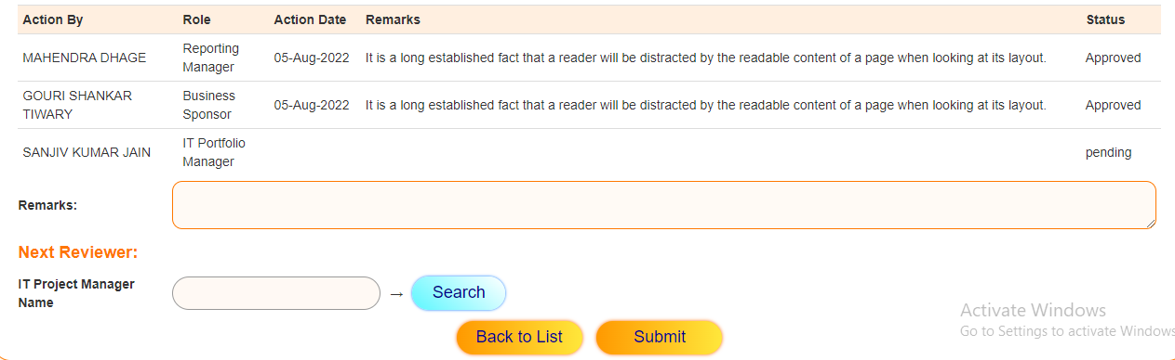
Prototype

Business Logic and Validations
Table 15: IT Portfolio Manager Approval form Field Business Logic 1
Field Name | Remarks
Input Format | Text Box [Multiline] (1 X 2 rows)
Maximum Length | 2000
Default Value | N/A
Data Entered By | User must enter value
Validation | Mandatory
Business Rules | N/A
Table 16: : IT Portfolio Manager Approval form Field Business Logic 2
Field Name | Next Reviewer
Input Format | Disabled Text Box
Maximum Length | N/A
Default Value | N/A
Data Entered By | Auto-populated on “IT Project Manager selection”
Validation | Mandatory
Business Rules | N/A
Table 17: IT Portfolio Manager Approval form Field Business Logic 3
Field Name | Submit
Input Format | N/A
Maximum Length | N/A
Default Value | N/A
Data Entered By | N/A
Validation | N/A
Business Rules | On click of this button, system will validate the form and submit the request. On submit the request and mail will be sent to the IT Project Manager.

IT Project Manager Approval

Overview
From the IT Portfolio Manager the request will come to the IT Project Manager. Post logging in to the application the user needs to redirect to the My Tasks page. The user can view & act on all the request assigned. The user will have the option to view the data entered in the previous stages in non-editable mode. The user must enter all the Impact Assessment field’s and enter his remarks on this request. On submit, email notification will be sent to the IT Portfolio Manager.

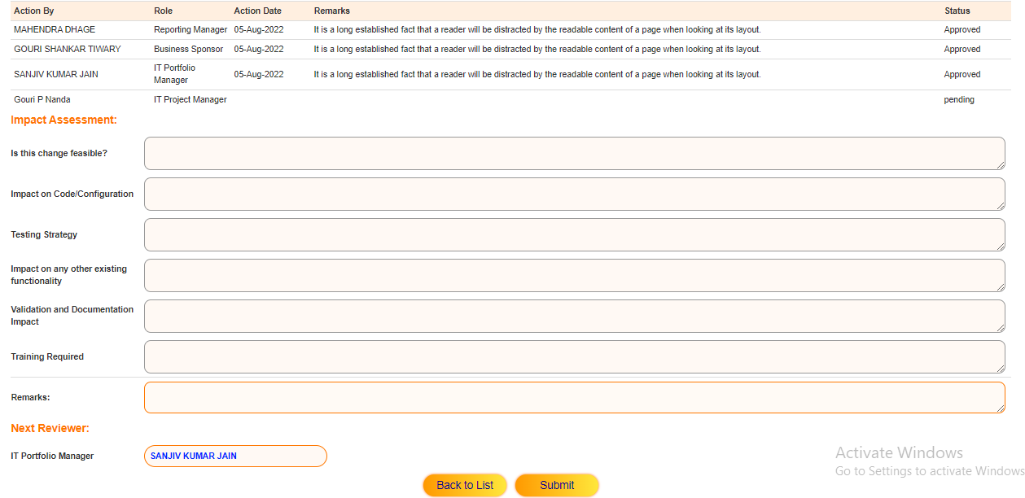
Prototype

Business Logic and Validations
Table 18: IT Project Manager Approval form Field Business Logic 1
Field Name | Is this change feasible?
Input Format | Text Box [Multiline] (1 X 2 rows)
Maximum Length | 2000
Default Value | N/A
Data Entered By | User must enter value
Validation | Mandatory
Business Rules | N/A
Table 19: IT Project Manager Approval form Field Business Logic 2
Field Name | Impact on Code/Configuration
Input Format | Text Box [Multiline] (1 X 2 rows)
Maximum Length | 2000
Default Value | N/A
Data Entered By | User must enter value
Validation | Mandatory
Business Rules | N/A
Table 20: IT Project Manager Approval form Field Business Logic 3
Field Name | Testing Strategy
Input Format | Text Box [Multiline] (1 X 2 rows)
Maximum Length | 2000
Default Value | N/A
Data Entered By | User must enter value
Validation | Mandatory
Business Rules | N/A
Table 21: IT Project Manager Approval form Field Business Logic 4
Field Name | Impact on any other existing functionality
Input Format | Text Box [Multiline] (1 X 2 rows)
Maximum Length | 2000
Default Value | N/A
Data Entered By | User must enter value
Validation | Mandatory
Business Rules | N/A
Table 22: IT Project Manager Approval form Field Business Logic 5
Field Name | Validation and Documentation Impact
Input Format | Text Box [Multiline] (1 X 2 rows)
Maximum Length | 2000
Default Value | N/A
Data Entered By | User must enter value
Validation | Mandatory
Business Rules | N/A
Table 23: IT Project Manager Approval form Field Business Logic 6
Field Name | Training Required
Input Format | Text Box [Multiline] (1 X 2 rows)
Maximum Length | 2000
Default Value | N/A
Data Entered By | User must enter value
Validation | Mandatory
Business Rules | N/A
Table 24: IT Project Manager Approval form Field Business Logic 7
Field Name | Remarks
Input Format | Text Box [Multiline] (1 X 2 rows)
Maximum Length | 2000
Default Value | N/A
Data Entered By | User must enter value
Validation | Mandatory
Business Rules | N/A
Table 25: IT Project Manager Approval form Field Business Logic 8
Field Name | Next Reviewer
Input Format | Disabled Text Box
Maximum Length | N/A
Default Value | IT Portfolio Manager selected previously by Business Sponsor
Data Entered By | N/A
Validation | N/A
Business Rules | N/A
Table 26: IT Project Manager Approval form Field Business Logic 9
Field Name | Submit
Input Format | N/A
Maximum Length | N/A
Default Value | N/A
Data Entered By | N/A
Validation | N/A
Business Rules | On click of this button, system will validate the form and submit the request. On submit the request and mail will be sent to the IT Portfolio Manager.

Final IT Portfolio Manager Approval

Overview
From the IT Project Manager the request goes to the IT Portfolio Manager after his review and assessment. Post logging in to the application the user goes to the My Tasks screen. The user can view & act on all the request assigned. The user will have the option to view the data entered in the previous stages in non-editable mode. The user need to enter his remarks on this request and do the final Approval (Yes/No). On Submit, email notification will be sent to all the previous reviewers and initiator regarding approval or rejection.

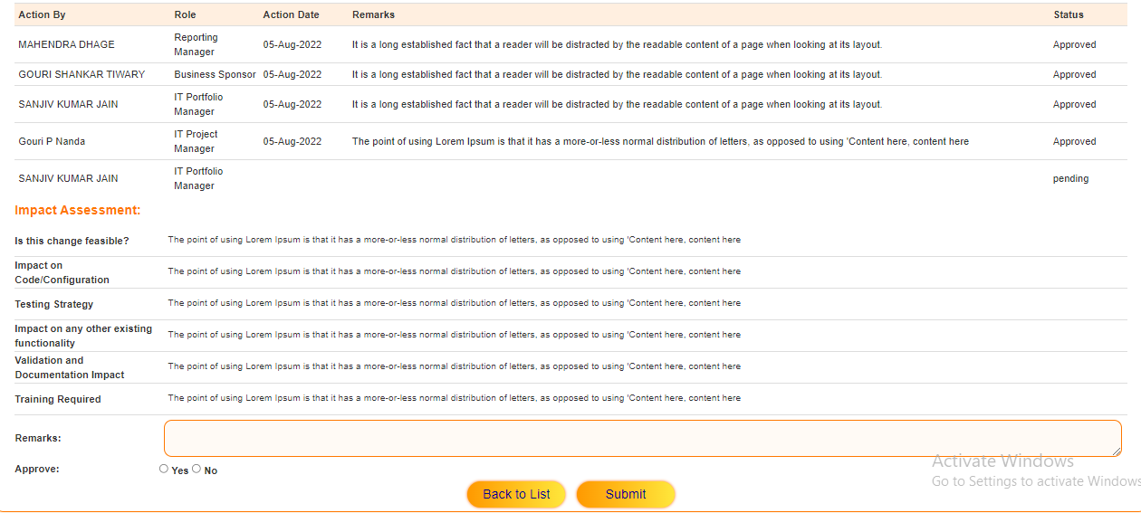
Prototype

Business Logic and Validations
Table 27: Final IT Portfolio Manager Approval form Field Business Logic 1
Field Name | Remarks
Input Format | Text Box [Multiline] (1 X 2 rows)
Maximum Length | 2000
Default Value | N/A
Data Entered By | User must enter value
Validation | Mandatory
Business Rules | N/A
Table 28: Final IT Portfolio Manager Approval form Field Business Logic 2
Field Name | Approve
Input Format | Radio Button
Maximum Length | N/A
Default Value | N/A
Data Entered By | User must select Yes/No
Validation | Mandatory
Business Rules | N/A
Table 29: Final IT Portfolio Manager Approval form Field Business Logic 3
Field Name | Submit
Input Format | N/A
Maximum Length | N/A
Default Value | N/A
Data Entered By | N/A
Validation | N/A
Business Rules | On click of this button, system will validate the form and submit the request. On submit, mail will be sent to all the previous reviewers and initiator.

Tools / Technologies / Third Party Components
            - Entity Framework using .net version 4.6
            - Microsoft .net
            - Microsoft SQL Server.
            - Microsoft Windows Server
            - Tool used: Visual studio 2015

Future Scope
- Change Request Approval process is currently only for initiating New Project Request. Further should be expanded for Change in Existing Project Request.
- Current process is not dynamic. It can be improved if initiator have choice to send request directly to IT Portfolio Manager.

Conclusion
Technical Learnings:
- First I learned MS SQL Server Management Studio.
- Learned MS-SQL procedures, functions, and views in database.
- Also I learned about asp.net MVC with Entity Framework and created the Change request Approval Process project on the same.
Other Learnings:
- It was my first professional experience, so I learned how to work and behave in professional environment.
- I got exposure of the office environment, so I learned all official behaviors like how to sit constantly for 4-5 hrs, how to talk with seniors, how to discuss and resolve issues and how to work in a team.
- I got to know how the importance of professional ethics and good communication.
- Also learned about time management, completing work on time and coming on time.

Thank You

Document Review Comments
Issue No | Page No | Paragraph/ Section No | Originator (Initials) | Issue  (Question, Comment, Suggestion, Etc.) | Resolution  (Historical, Justification, Decision, Etc.) | Concur  (Initials)

NOTES :

